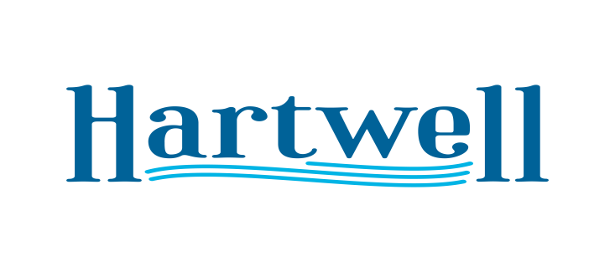
A G E N D A

January 3rd 2022

- Call to Order
- Invocation / Pledge
- Mayor Comments: Swearing in Mayor and Council Members
- Approve Minutes
- HYDRA Music Festival: May 28th Hartwell Lakeside Resort
- Alcohol License Approval: 329 Steakhouse
- Annexation and Zoning (R-2) 1st Reading: Ridge Rd Development LLC
- Executive Session: Real Estate
- Adjourn

