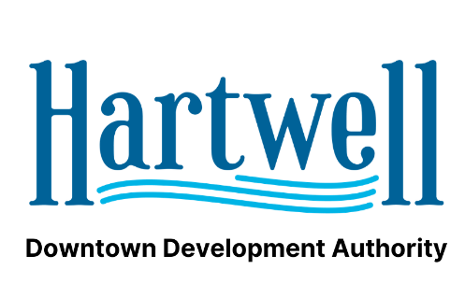
AGENDA
Hartwell DDA - Hartwell Main Street
June 16th, 2021
City Hall

- Call to Order: Chair Person
- Approval of minutes for May Meeting
- Chairman’s Report: Carey Jackson
- Treasurer’s Report: Alice Glenn
- Director’s Report: Jason Ford – Georgia Downtown Conference – Georgia Main Street Visit – Yearly Retreat
- Main Street Report: Peggy Vickery
- Public Comment
- Adjourn

