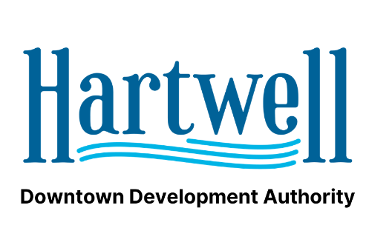
AGENDA
Hartwell DDA - Hartwell Main Street
April 21st, 2021
City Hall

- Call to Order: Chair Person
- Approval of minutes for November Meeting
- Chairman’s Report: Carey Jackson
- Treasurer’s Report: Alice Glenn
- Director’s Report: Jason Ford
- Main Street Report: Peggy Vickery
- Public Comment
- Adjourn

