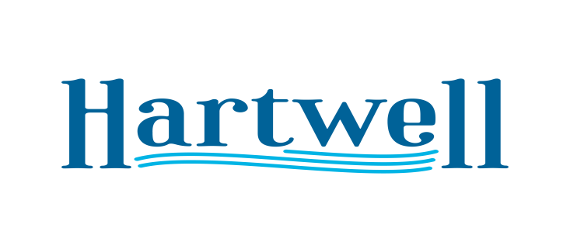
A G E N D A

February 5, 2024

- Call to Order
- Invocation / Pledge
- Mayor Comments
- Approval of Minutes
- Black History Proclamation
- Hartwell Service League Pre-4th Celebration June 29th
- Depot Days/HartTober Fest
- Hartwell Lakeside Music Festival
- Markers Festival April 27th
- Alcohol License
- 1st Reading Annexation/Zoning Case 2023-08
- Urban Camping 1st Reading
- Adjourn

