PUBLIC HEARING MINUTES
The Hartwell Planning & Zoning Commission held a rescheduled Public Hearing called on November 29th, 2022 at 6:00 p.m. in the Council Chambers at City Hall.
Zoning Board members present were Michelle Wetherbee, Erin Gaines, Jermaine Durham, Tina Howard, Lenford Smith, and Mary Gidley, and Carter Schell.
The meeting was called to order by Chairwoman Michelle Wetherbee, and led the hearing with the Pledge of Allegiance.
Chairwoman Wetherbee welcomed Carter Schell, the newest member of the board.

Mary Gidley motioned to approve the agenda, which was seconded by Lenford Smith. All voted unanimously to approve.

Lenford made motion to accept the minutes from September and October meetings, which was seconded by Tina Howard. All voted unanimously to approve.

Michelle Wetherbee explained decorum and processes for the hearing.

Case 2022-06 – Annexation and zoning of Tax Parcel(s) C70C 002, I70F 009, and I70F 001 002

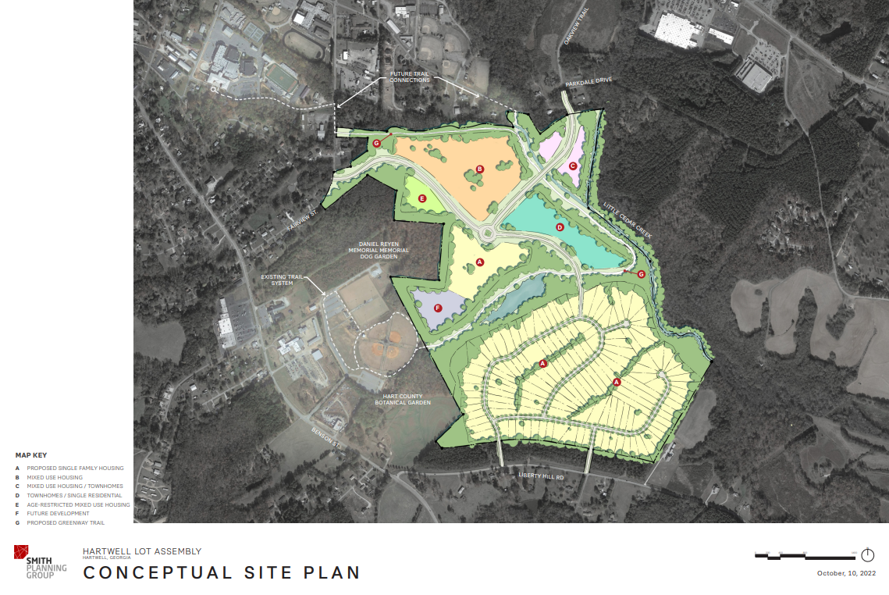

Kenny Whitworth spoke on behalf of the petitioners. He sited the City’s Comprehensive Plan in several locations (pp. 8, 24, and 43). He stated that this was a 10–15-year project, and this will not have an immediate impact. This housing project will be good for business and will be workforce housing. The development is approximately 274 acres and is a combination of three tracks. Some of it is already in the city. This meets all the legal requirements to annex. The concept plan is asking for single family residential attached/detached housing – townhomes including 55+ active adult community. The city has sewar needed to develop the property and access to utilities. It will provide greenspace, walkways, buffers, bike trails, and sidewalks. They have spoken with the Botanical Garden and they want to work with the community. His partner owns Oakview Crossing and is adding commercial and walkways throughout that.

Henry Keasler of Fairview Avenue spoke in opposition. He is concerned with traffic. Part of this has access on one side of other of the church (on Fairview). There is nothing to absorb this traffic. There are several cutout/driveways on Fairview. There are safety concerns with the 45-mph speed limit. He stated that Liberty Hill has similar issues with traffic. The take out on Parkdale has a legitimate concern. He said residential growth tends to be a drain on resources. He cited page 30 of the City Comprehensive Plan. He was disappointed that the City Council had a public hearing prior to the Planning and Zoning Commission. He wants to consider the schools, and that he has lived on 25 years. He just wants the board to listen to the constituents.

Helen Fleming spoke in opposition. She asked if a referendum was appropriate.

Ann Perry Ayers spoke in opposition. She asked for a traffic study.

Linda Mueller spoke in opposition – She stated it is hard to get out on roads. Other subdivisions they have done are still waiting on things promised to them.

David Thompson spoke in opposition – Consider the county as part of the city. Especially emergency services. It is hard to get an ambulance. Landfill services would go up, and traffic. There are only two ways to go around the lake – Highway 29 or up 85.

Brian Thompson spoke in opposition – have to look at the size of the subdivision. There are too few firefighters in Hart County. Liberty Hill has no volunteers. Workforce for EMS and fire are strained.

Mike ? – Spoke in opposition – This will create a 50% increase in schools and schools are pricey.

Kevin Thompson – His family has been in EMS/Fire for over 4 decades. First responder standpoint the development is not going to work. There is a school strain. The plan was put forth too fast. There are too many unknowns. He is concerned about the creek.

Alan Duncan spoke in opposition – They want to be in the city but the development could be done in the county.

Kenny Whitworth rebutted – lots of planning has gone into the development. Still has to do engineering once they know if they are allowed to annex. He stated that Jon Herschell ran numbers about if it is affordable for the city and stated it is. He said Elbert County is losing population and schools are shrinking. They are willing to increase buffers. He knows other large developments like this one. He stated he has never left any project where somebody needed something done. He knows the City Manager has check on quality of work in other communities. He understands traffic concerns and is willing to have a traffic study done.

Zoning Administrator talked about the GMRC DRI recommendations and that those are incorporated into a recommendation list. The recommendation from the zoning administrator is as follows:
Recommend to the Zoning Board to recommend to City Council that the property is annexed and zoned R1 with conditions.
- Provide Operating Agreement to clarify party responsibilities in the petition
- Single family residential – detached/attached
- Density – Per R1 zoning and health department requirements – Proposed Section A – 2 units per acre to accommodate service delivery in regards to septic tank requirements, in all other areas 2.9 units per acre after the design achieves compatibility with existing neighborhood designs, and after the green space, public spaces, and roads are designed allowing for 30 ft. undisturbed setbacks on the circumference of the property, as well as additional setbacks from all water sources addressed specifically in subsequent conditions (i.e., ponds, creeks, etc.)
- Phased development over a minimum of 10 years – start using the conceptual site plan as a marker, complete all infrastructure for the entire project and then develop housing product starting in proposed areas E & B
- Per GMRC DRI Recommendations – additional roads in the neighborhood will need to be built as well as additional improvements to existing roadways including sidewalks, curbs, and gutter
- Per GMRC DRI Recommendations - Prior to Chapter 32 subdivision applications, complete a traffic study with GDOT or “other traffic engineers” at the intersections SR77 and Liberty Hill Road and SR8 and Oakview Trail to bring road conditions to GDOT standards. Based on this study it is possible that a mitigation of traffic may require additional access points, a redirection of traffic, or possibly a reduction in the number of proposed units
- Complete all Chapter 32 Subdivision petitions in public hearings including any minor subdivisions as defined by the City of Hartwell Code of Ordinances. All Chapter 32 requirements must be met prior to the city accepting a petition
- Per GMRC DRI Recommendations - Internal pedestrian amenities such as sidewalks and proposed trail/greenway should connect to the County Recreation Center and the High School
- Per GMRC DRI Recommendations, As noted above, the developer must maximize efforts to retain the integrity of Little Cedar Creek via a 50 ft. buffer and other measures to prevent further contamination risk for the body of water. The same buffer should be in place around the pond that is central to the property
- The area on the conceptual plan provided marked “future growth (Area F)” should remain as a passive greenspace area to provide additional buffer to the County recreation area
- Increase passive greenspace area on the side of the proposed road in the development nearest to the Botanical Garden in proposed section A – 100 ft. undisturbed buffer
- Per GMRC DRI Recommendation the developer should consider cooperation with the County Parks and Recreation Area concerning not only access to the land but also possible set asides for future park development.
- 55+ community housing in proposed areas E & B
- Hardy plank, brick, stick built
- Encourage housing product based on median household income for the area
- Require HOA for maintenance of common areas
- All conditions are in perpetuity regardless of owner
- Require bonds from developer for roads
Mary Gidley asked who pays for the infrastructure. Jon Herschell answered that the developer does.

Dr. Durham asked about conditions and the process for Chapter 32 of our subdivision ordinance. He stated that we do need more housing while we appease the concerns. Rob Leverette answered the questions about the process and that we can require bonds.

Tina Howard asked about breaking the annexation into smaller parts. Kenny Whitworth answered that it is more feasible to build at one time because of costs.

Tina Howard shared concerns about the development threatening downtown and that we need housing like what they are proposing.

Kenney Whitworth responded that they are looking to bring additional grocery stores at Hwy 29. It won’t be a draw from downtown. There will be no businesses in the community and that people will go downtown. This development will enhance it.

Erin Gaines had concerns about school size. She asked Jennifer Carter (Superintendent of Hart County Schools) to address school capacity. She stated that the school board chooses not to take an official position but Hartwell Elementary and North Hart Elementary are close to being full. One remedy is to redraw lines, which might mean moving schools. She stated the middle school and high school were pretty full. Mary Gidley asked her about class size. Dr. Durham asked about school capacity. Superintendent Carter said there was not much left and the schools are very landlocked. She also said it is not just classrooms and teachers but student services that are impacted as well. Carter Schell asked about growth of schools. Mrs. Carter stated that schools have to present a need before they can grow.

Brent Bentley (one of the developers) responded to concerns saying this will be a walkable and bikeable community. This will pull car traffic off the roads.

Michelle Wetherbee - what is the buildable acreage? Brent Bentley answered the answer was hard to determine until we know what we can annex.

Carter Schell asked if a feasibility study had been conducted and the developer said no.
Lenford Smith asked about the current Liberty Hill development.

Erin Gaines asked the developers if the discussed study’s come back as unfavorable are they still willing to take the risk. They answered they have already undertaken significant risk by purchasing the property.

Michelle Wetherbee called for a 5 minute break.

Tina Howard asked about the arbitration process (as the annexation has been objected to by the Hart County Board of Commissioners). Marshall Sayer (Chairman) stated their objection was based on density, services, traffic, county infrastructure, the need four more EMS workers per shift to meet demand.

Dr. Durham asked about the potential price points. Kenny Whitworth stated there would be varying price points – the desire being that people could phase up. The market will determine price.

Carter Schell asked if their business plan worked at the max density only. The developers said that their business plan worked at the R1 density requested.

General discussion was held with multiple people speaking.

Dr. Durham made a motion to approve the annexation with R1 zoning and conditions recommended by the zoning administrator. Lenford Smith seconded but asked if they could amend for 100 ft. buffer. Legal Council advised to make a vote to amend the motion to include the 100 ft. buffer. That motion failed with a 3-3 vote. Carter Schell abstained.

Lenford Smith seconded the original motion. 3 voted in favor, 3 voted against with Carter Schell abstaining.

Tina Howard restated her concerns about doing it over time and what happens if they don’t develop. Robert Leverette stated the bond protects the city, and Tina responded but not the neighbors.

General discussion was held about what happens if no recommendation is made. Rob Leverette that our ordinance says if no recommendation is made in 30 days, then it is deemed to have passed without condition. Carter Schell stated he was concerned that if no recommendation is made, the voices of the public would not be herd. Rob Leverette asked him to clarify his recusal. Carter Schell stated because one of the speakers asked since he was not involved from the beginning. He had no financial benefits from the project and rather than not have a tie and no voices he chose not to recuse. Rob Leverette clarified that it was appropriate.

Dr. Durham said the boards obligation is fulfil the obligations of the Comprehensive Plan of the City of Hartwell. This proposal meets the legal requirements and that is the reason behind his motion – is it legal, and does it meet the Comprehensive Plan, and that their role was not to pick apart a business plan.

Dr. Durham restated his original motion and it was seconded by Lenford Smith. The board voted in favor of recommending the property be annexed and zoned with the aforementioned conditions 4-3. Michelle Wetherbee, Carter Schell, Jermaine Durham, and Lenford Smith voted in favor. Mary Gidley, Erin Gaines, and Tina Howard voted against.

Case 2022-07, Rezoning of parcel I56L 160 from R1 to R1B

Scott Appling presented a plan to develop the aforementioned parcel. He proposed cottage style housing. This is still a single-family residential development, just with more density. It matches the area. The homes are designed for professionals and retirees that could afford more but don’t want extra maintenance.

Zoning Administrator recommended approval.

Mary Gidley asked what type of housing.

Tina Howard asked about market demand.

Toy Wilkinson made comments about an unrelated area of the city.

Mary Gidley made a motion to approve the rezoning of the parcel from R1 to R1B. Lenford Smith seconded. The vote was 7-0 in favor of recommending rezoning the parcel to the City Council.

Michelle Wetherbee thanked the board and citizens for their comments and work.

Tina Howard made motion to adjourn, Jermaine Durham seconded. All voted in favor.

The meeting was adjourned – 9pm.

Faithfully submitted,

Jason Ford
Zoning Administrator

