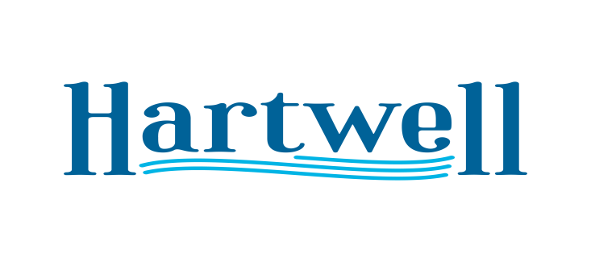
A G E N D A

January 8, 2024

- Call to Order
- Invocation / Pledge
- Mayor Comments
- Swearing in New Councilmen: Zach Adams and Richard Sheller
- Veterans Day Parade: Sunday Nov 10th 2024
- Approve Official Zoning Map
- Adjourn

